7.2.10 Editors - 3D View - Header - Weight Paint mode menus
Detailed Table of content 1
Weight Paint Mode - Select Menu 2
Linked 2
Linked Pick Select 2
Linked Pick Deselect 2
Ungrouped Verts 2
Last Operator Select Ungrouped 2
Extend 2
Inverse 2
(De)Select All 3
Last Operator (De)Select All 3
Action 3
Invert 3
Deselect 3
Select 3
Toggle 3
Circle Select 3
Border Select 4
Lasso Select 4
Weight Paint Mode - Weights Menu 4
Set Weight 4
Assign from Bone Envelopes 4
Assign Automatic from Bones 5
Last Operator Weight from Bones 5
Type 5

Detailed Table of content

Weight Paint Mode - Select Menu

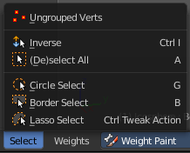
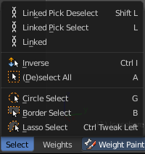
The Select menu in Weight Paint mode provides you with some selection tools for masking. This menu is just visible when you have either Face selection masking or vertex selection masking activated. The content differs between those two modes. Ungrouped Verts is just visible with Vertex Selection masking. The three "Linked" menu items just with Face Selection masking.

Linked
Just active with Face selection masking. Select linked faces.

Linked Pick Select
Just active with Face selection masking. Hotkey Only Functionality! This entry exists so that you know the tool is there and that you can edit the hotkey.
Linked Pick Select selects the linked faces under the cursor.

Linked Pick Deselect
Just active with Face selection masking. Hotkey Only Functionality! This entry exists so that you know the tool is there and that you can edit the hotkey.
Linked Pick Select deselects the linked faces under the cursor.

Ungrouped Verts
Just active with Vertex selection masking. Selects ungrouped Vertices.

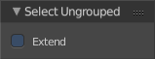
Last Operator Select Ungrouped

Extend
Extends the selection.

Inverse
Inverts the current selection.

(De)Select All
Toggles between select all and deselect all.

Last Operator (De)Select All

Action
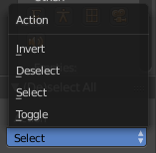
Action is a drop-down box where you can choose between different methods.

Invert
Inverts the selection.

Deselect
Deselects all.

Select
Selects all.

Toggle
Toggles between select all and deselect all.

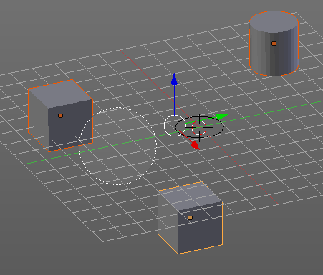
Circle Select
Circle select enters the Circle Select mode. This is a special select mode where you can select elements by moving with the mouse over it. It adds to selection by default.
To subtract from selection hold down Shift key. To exit the Circle select click with the right mouse button.
The pencil radius of the circle select tool can be adjusted with the scroll wheel.

Note
You cannot navigate while you are in Circle Select mode. You have to leave the Circle Select mode, do the navigation, then re enter the Circle Select mode.

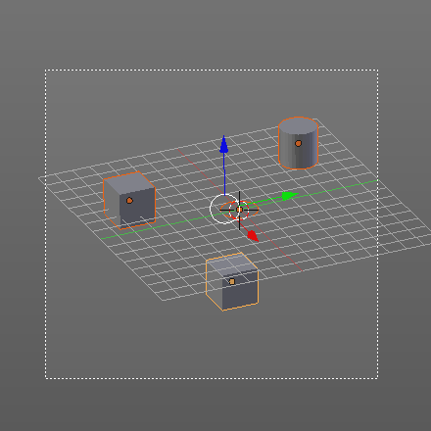
Border Select
Border select enters the Border Select mode. This is a special select mode where you can select elements by dragging a rectangle. And what's inside of the rectangle gets selected then. It adds to selection by default.
To subtract from selection hold down Shift key.
The selection gets applied when you release the mouse. You leave the mode automatically when you release the mouse.

Lasso Select
Lasso select enters the Lasso Select mode. This is a special select mode where you can select elements by dragging a form around what you want to select. And what's inside of the rectangle gets selected then. It adds to selection by default.
To subtract from selection hold down Shift key.
The selection gets applied when you release the mouse. You leave the mode automatically when you release the mouse.

Note
You can of course also start with clicking at the menu item. But this tool is by design a hotkey only tool. Hold down Ctrl , and select with left mouse button.

Weight Paint Mode - Weights Menu
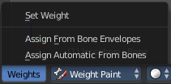
The weights menu contains some tools around Weight Painting.

Set Weight
This tool is just active when you have either Face selection masking or vertex selection masking activated.

The tool fills the selection with the current active Weight color that you have adjusted in the Brush panel in the Tools tab in the Tool shelf.

Assign from Bone Envelopes
Weights the vertices from the connected bone envelopes. And takes the distance to the bone envelope into account.

Assign Automatic from Bones
Weights the vertices connected with the bone. And takes the distance to the bone into account.

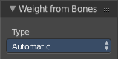
Last Operator Weight from Bones
This last operator is the same for both tools. Assign Automatic from Bones, and Assign from Bone Envelopes.

Type
Here you can choose if you want to Assign from Bone Envelopes, or from Bones.

